Thermal Imaging Application Upgrade Guide

Upgrade steps:
- On the computer, copy the upgrade package Upgrade.zip to the root directory of the SD card, decompress it to the current folder, and after decompression, you can see an Upgrade folder. After the steps are completed, take out the SD card;
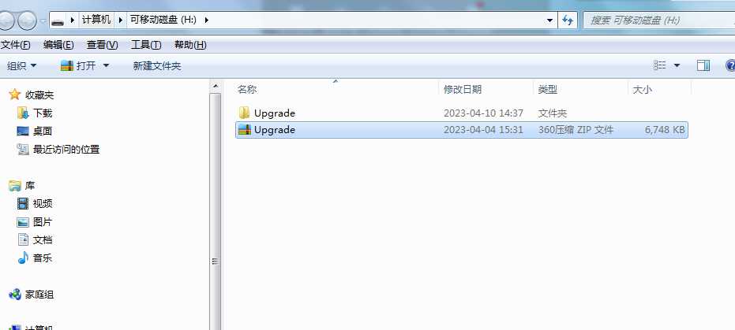
- Insert the SD into the SD card slot of the thermal imager. After starting up, press and hold the "left button" and "right button" at the same time on the main interface of the thermal imager until the upgrade interface appears, and let go;
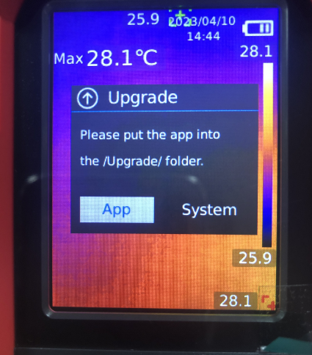

- In the upgrade interface, select the "App" button, press the SET button, wait a few seconds, the interface will prompt "UpgradeOK", then press and hold the power button to shut down;
x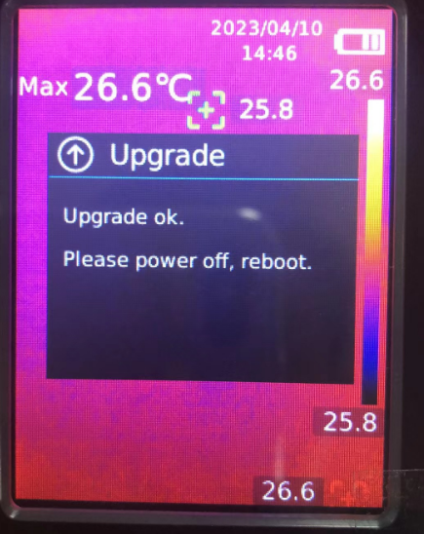

4 Long press the power button to turn on the device. On the main interface of the thermal imager, press and hold the "left button" and "right button" at the same time until the upgrade interface appears, then let go;
- On the upgrade interface, select the "App" button, press the SET button, wait a few seconds, the interface will prompt "UpgradeOK", then press and hold the power button to shut down;
6. Reboot normally, the upgrade is successful

